# Web Technology 1

# Assignment 1

Nagizkhanov Amir

SE-2416

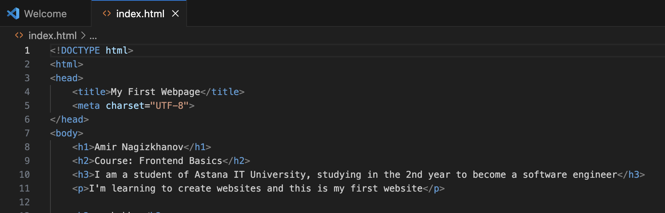

This section displays the titles and text on the page.

<h1>, <h2>, <h3> are headings, from biggest to smaller.

<p> is a paragraph of regular text.

Used to show your name, the topic of the site, and a short description.

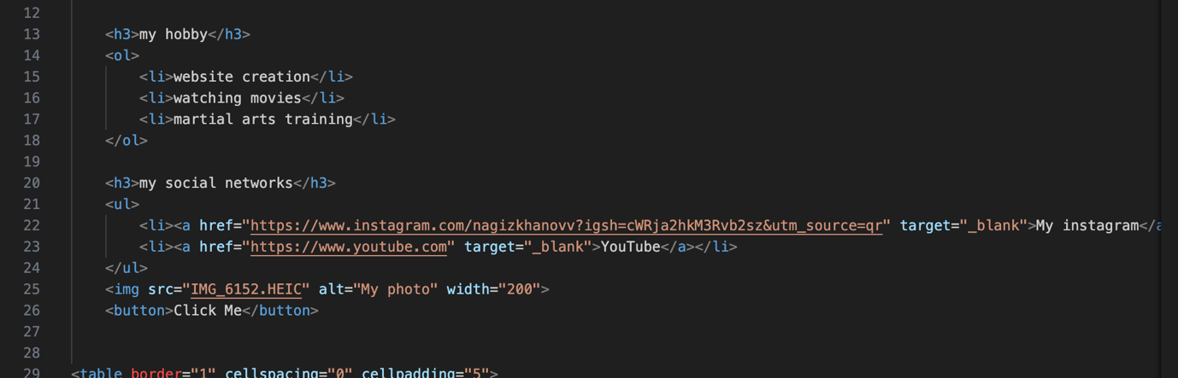

Lists

This section shows two types of lists:

<ol> is an ordered list (with numbers, when the order matters).

<ul> is an unordered list (with bullet points, when order doesn't matter).

Each item in the list is inside <li> (list item).

Used here to show hobbies and favorite links.

Image and links

This section includes:

<img> to insert an image (your photo), with:

src: the image URL,

alt: alternate text (if image doesn't load),

width: image width in pixels.

<a> are hyperlinks to other websites.

target="_blank" makes the links open in a new tab.

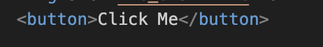

Button

This adds a button with the text "Click Me".

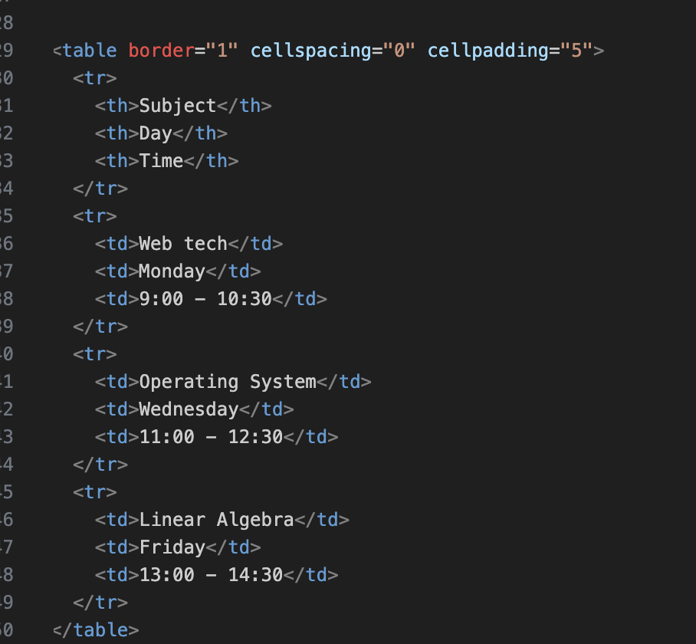

**Table (schedule)**

**This is a table showing your class schedule:**

**<table> is the container.**

**<thead> contains column headers: Subject, Day, Time.**

**<tbody> contains the actual data rows.**

**<tr> = table row, <td> = table cell, <th> = header cell.**

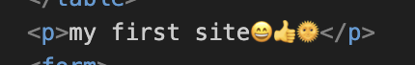

Just emojis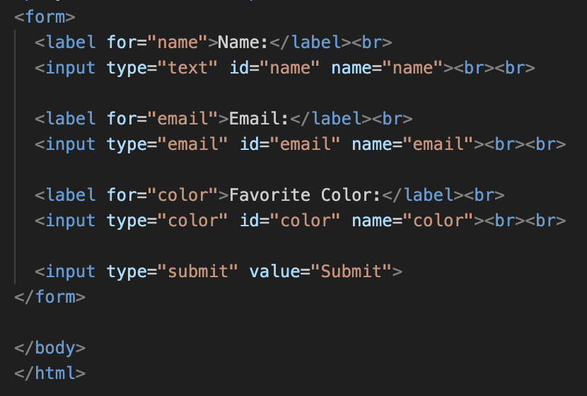

This is a **form** where users can enter and send information:

<form> starts the form.

<label> gives a name to each input field.

<input> allows the user to type:

Text (type="text")

Email (type="email")

Pick a color (type="color")

Submit button (type="submit") sends the data.